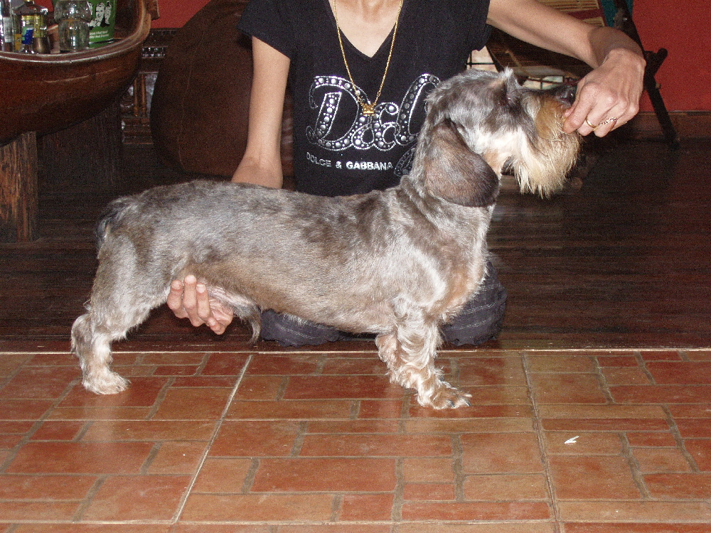

FATHER
Ch. Jesse James of Delatro (JJ)
Isha
Ch. Vom Kuisebknie Grimm

Ch. Ritlo Making Merry
Ch. Vom Kuisebknie Grimm
Igelbau Cambo of Kuisebknie
Vomkuisebmund Gina

Ch. Varsha's Dynamic (Tiger)

Ch. Varsha’s Live Wire

MOTHER
Windward’s Earl
Ch. Varsha's Jive Dancer (Simba)

Windward’s Cleopatra (Isabelle)
Ch. Jesse James of Delatro (JJ)
Ch. Varsha’s Live Wire
Ch. Jesse James of Delatro (JJ)
Sally

Ch. Varsha’s Lotus (Honey)
Ch. Jesse James of Delatro (JJ)
Ch. Varsha’s Live Wire
Ch. Vom Kuisebknie Grimm
Isha
Igelbau Cambo of Kuisebknie

Vomkuisebmund Gina
Ch. Vom Kuisebknie Grimm

Ch. Ritlo Making Merry
Windward’s Tessie

PUPS - LITTER 2
Ch. Jesse James of Delatro (JJ)

Ch. Vom Kuisebknie Grimm

Isha
Ch. Varsha's Jive Dancer (Simba)

Ch. Varsha’s Live Wire

Windward’s Pups – Litter 2

Ch. Varsha's Jive Dancer (Simba)

Windward’s Earl

Windward’s Cleopatra (Isabelle)
Windward’s Tessie

Ch. Varsha's Jive Dancer (Simba)

Ch. Varsha’s Lotus (Honey)

Ch. Varsha’s Live Wire

